ADRIAN TURION |  | Avenue de Sainte-Clotilde 9  1205 Geneva, Switzerland | 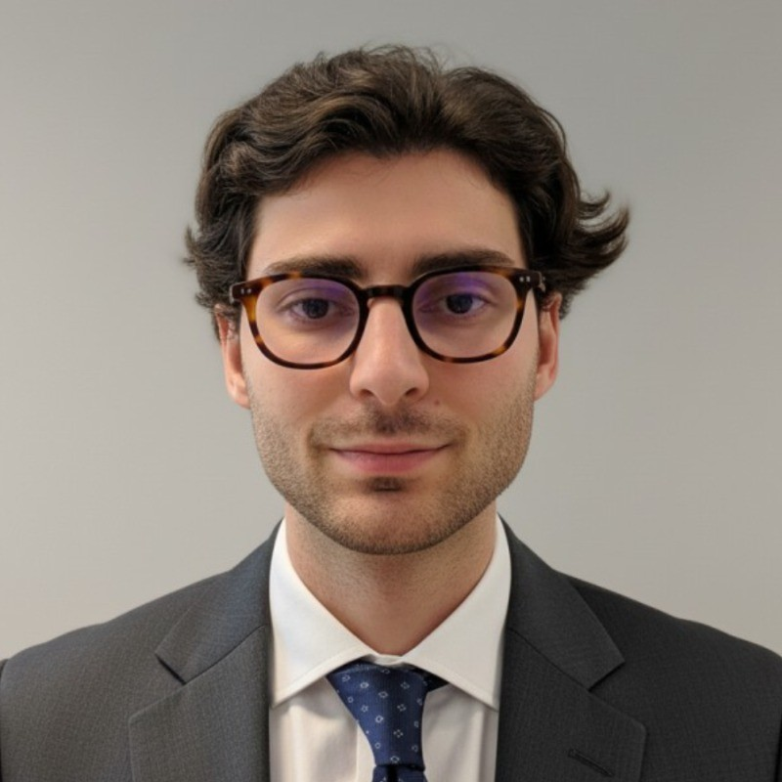
turionadrian@gmail.com | Swiss | 10.11.2000 |  | +41 77 262 37 96
INTRODUCTION
Trading product-focused MSc Finance candidate with derivatives, fixed income, and equity knowledge from coursework and active options portfolio management. Strong coordination skills developed managing concurrent workstreams and cross-functional stakeholders. Process optimization mindset demonstrated through automated dashboards and data pipeline development.
WORK EXPERIENCE
Auraïa Capital Advisory – Small & Mid Cap Cross-border M&A Boutique  Mergers & Acquisitions Analyst (Converted internship into full-time position) |  | Geneva, Switzerland  Aug 2024 – Current
- Staffed on 7 live mandates across healthcare, tech, and financial services with deal values from EUR 5M to EUR 50M, managing concurrent workstreams including valuations, due diligence, and process coordination with external advisors.
- Built detailed financial models (DCF, trading comps, precedent transactions) and prepared client presentations for Board meetings, translating complex financial data into actionable insights for senior stakeholders.
- Coordinated with legal, tax, and accounting advisors to structure transactions and negotiate deal terms, ensuring alignment between business requirements and technical execution across multiple parties.

RC Group – Currently under LBO with Crédit Mutuel Equity  Mergers & Acquisitions Intern |  | Paris, France  Feb 2024 – Aug 2024
- Conducted financial and operational due diligence on targets with revenues of EUR 10M-30M, analyzing market trends, competitive positioning, and financial projections to identify key value drivers and support acquisition decisions for the CEO of Healthcare and Retail divisions.

Europ Assistance – Subsidiary of Generali Insurance  Financial Analyst Intern |  | Geneva, Switzerland  Apr 2023 – Aug 2023
- Built automated financial dashboards in Excel and PowerBI to track KPIs and performed variance analysis on monthly P&L results for a CHF 50M+ subsidiary, supporting the CFO in identifying operational efficiency improvements and reporting anomalies.

LEADERSHIP
- Founded Screeny.ai, an AI-driven software for investment banks to identify acquirers, reducing buyer search time from 10h+ to 20min and securing adoption by 3 advisory firms.
- Finalist in McKinsey-sponsored case competition, developing a predictive model for black swan events using order book data with potential CHF 200K annual revenue impact.
- Manage personal investment portfolio using options strategies (Cash Secured Puts, Covered Calls) on derivatives with 45-day expiries, achieving 8% annualized returns.
EDUCATION
HEC Lausanne  Master of Science in Finance |  | Lausanne, Switzerland  2021 – 2024
- Cumulative GPA: 5.2/6.0 (Top 15% of the class cohort)
- Exchange programs at Waseda University (Tokyo, Japan) and Maastricht University (Maastricht, Netherlands)
- Relevant Coursework: Derivatives, Fixed Income and Credit Risk, Quantitative Risk Management
- Thesis Topic: Synergies Analysis of the Merger between American Airlines & US Airways

Bachelor of Science in Management |  | 2018 – 2021
- Cumulative GPA: 4.7/6.0

Scientific Baccalaureate with Highest Honors (16.6/20) |  | Aix-en-Provence, France
ADDITIONAL INFORMATION
Languages:  Computer:  Interests:  References: | French (Native, C2), Spanish (Native, C2), English (Fluent, C1), German (Business proficient, B2-C1)  Financial Modeling | Derivatives | Process Optimization | SQL & PowerBI  Geopolitics, Badminton (Provence regional finalist), Gym, Real use cases of Artificial Intelligence  Guillaume Arnaldez – Ex-Director at Auraïa Capital Advisory, guillaume.arnaldez@auraia.ch  Sacha Caravatti – CFO at Europ Assistance Switzerland, scaravatti@europ-assistance.ch

